ANSWER KEY: Space Shuttle Word Search
Directions:
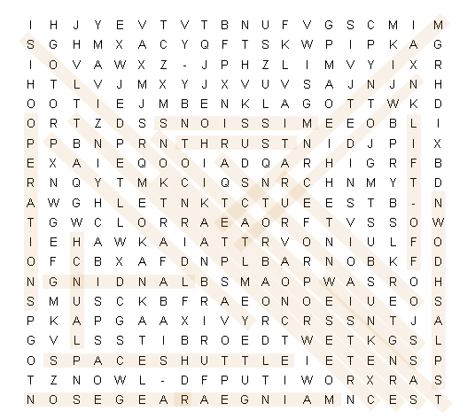
As you look for the hidden words below, remember that they can be horizontal, vertical, or diagonal—frontward or backward!

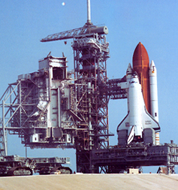
Word Bank
Astronauts  Crew Compartment  Deorbit  External Tank  Landing  Launch  Lift-Off  Main Gear  Maintenance  Missions  NASA  Nose Gear |  | Operations  Orbiter  Orbiter Insertion  Payload Bay  Solid Rocket Boosters  Space Shuttle  Splashdown  Tank Separations  Thrust  Touchdown  Wings

